RC-AM,C-Taino-Yucatan

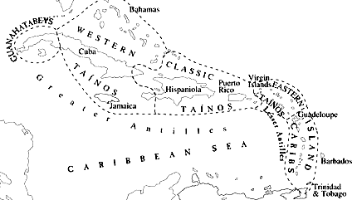

Fig. 1. Major cultural groups in the Caribbean, ca. 1492 (after Reid 2009: T-p.).

**Earliest Pre-ceramic Cultures of the Antilles**

**Casimiroid Culture**. Marine settlement of the northern Greater Antilles (western Cuba in the area of the Guanahatabeys on Fig. 1) by the **Casimiroid** culture from the lowlands of northeastern Yucatan in the area of Belize 5580+/- 80 BP (ca. 3500 BCE). This was accomplished by island hopping via a Mid-Caribbean chain of islands, which was exposed during the sixth millennium BCE due to a cold interim. Similarities of early macroblade assemblages (such as "sole-shaped" unifaces) of Maya lowland cultures and those of Cuba suggest a common heritage (Bullen 1976; Callaghan 1990; Coe 1957; Rouse 1960, 1992; Wilson, Iceland, Hester 1998; MacNeish and Nelken- Terner 1983).

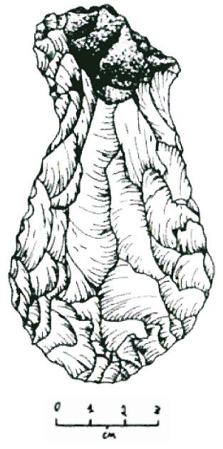

Fig. “Sole shaped” uniface or hafted digging tool presumably for marine mollusks (after Zeitlin and Zeitlin 2005:68).

The pre-ceramic **Casimiroid** culture concentrated on hunting, fishing and plant gathering and they increasingly became dependent on the littoral zones of the islands for subsistence on marine mollusks as the sea levels were lowered (Willey 1976). They continued to exist in extreme western Cuba until historic times when the Spanish called them the Ciboney. They spread southeastward to Hispaniola, where the earliest known sites of this culture are dated at ca. 4000 B.C.E.

**Banwari Culture**. The first settlement of the southern Lesser Antilles was from Trinidad ca. 5000 BCE by the **Banwari** culture, a hunting and shellfish-gathering culture that reached Puerto Rico by ca. 3000 BCE and Hispaniola by ca. 2000 BCE. The **Banwari** culture was noted for its coastal shell middens, which have yielded remains of their mixed economy: brightly colored gastropod mollusks (*Neritina virginea*), conches (*Melogena*), crab, deer, peccary, small mammals, and fish. Their stone tools consisted of ground stone pestles, manos, grooved axes, celts, and chipped projectile points and tools. Projectile points were also made of bone, as were needles and fishing spears (Harris 1976).

When the **Casimiroid** and the **Banwari** cultures converged on Hispaniola (Haiti and the Dominican Republic) in ca. 2000 BCE, new hybridized, pre-ceramic cultures developed as a result.

**Earliest Ceramic Cultures of the Antilles**

**Saladoid Culture.** Then in the last centuries BCE a **Barrancoid** ceramic culture from the lower Orinoco River Valley of Venezuela ventured as far north as Puerto Rico. This culture is known in the Caribbean as **Saladoid**, named after the Venezuelan site Saladero (Haag 1963:333-335). Shared Saladoid and Barrancoid ceramic techniques include vessel forms, such as zoomorphic effigy vessels, trays, and platters (some depicting animals native only to South America), jars and bowls with D-shaped strap handles, censers, and bell-shaped vessels. **Saladoid** potters decorated their vessels with polychrome designs in white-on-red, white-on-red with orange slip, black paint, and negative-painted designs. A smaller number of ceramics were decorated with designs incised into the body of the vessels. They planted cassava and other South American crops and continued to hunt and fish.

As these **Saladoid** people encountered earlier pre-ceramic settlers they incorporated their lithic technologies into new hybridized lithic-ceramic cultures. The **Saladoid** culture is noted for its diagnostic lithic artifacts: pendants shaped like raptorial birds endemic to South America made from exotic materials, such as amethyst, quartz, fossilized wood, jasper, greenstone, carnelian, lapis lazuli, turquoise, garnet, epidote distributed throughout the Greater and Lesser Antilles and northern South America suggesting a Pan-Caribbean trade network. This began the tradition of Taíno pendants which began with the emergence of the first chiefdoms ca. 700. CE.

**Ostinoid Culture.** Between 600 and 700 CE, Ostionoid culture migrants from the Orinoco area spread throughout the Antilles from South America (Stevens-Arroyo 1988) with developed permanent settlements, ceremonial centers, ball courts and a ceramic style with more incised decoration. This influx involved integration with the Saladoid culture, which continued the earlier patterns of agriculture, and village life. Trade and exchange between the Antilles and mainland South America diminished but regional Caribbean ceramic styles and the size and complexity of communities expanded with a ranked hierarchy of chiefdoms emerging.

**Mellacoid (or Meillacan) Culture**. Archaic **Casimiroid** people, who had been in Hispaniola for over 4,000 years, integrated with the new immigrant Ostionoid people ca. 600-700 CE. **Casimiroid** people were expert fishers, hunters and gatherers with an expert knowledge of the insular flora and fauna. In their interaction with the Ostionoid people they evolved into the hybrid **Mellacoid** (or Meillacan) culture that retained much of the Casimiroid knowledge of and veneration for the creatures and plants of the land and the sea (Wilson 2007: 101). These creatures became the subjects of their zoomorphic appliqué designs in their pottery, which was often decorated with rectilinear incisions, cross-hatched designs and punctuations. Their design grammar became the basis for the succeeding ***Taíno*** wood, ceramic and stone artistic forms.

**Taíno Chiefdoms**. “***Taíno***” derives from *nitaíno*, meaning “noble” or “good,” but the name is not related to any single monolithic culture as the previous discussion has sought to explain. The Caribbean by 700 CE was a mixture of many different cultures in diverse patterns of integration with each other, so that *Taíno* really refers to a supra-cultural mosaic of chiefdoms based on **Casimiroid**, **Banwari, Ortoiroid,** and **Saladoid** cultural expressions (Peterson et al. 2004:19; Oliver 2009:27-8).

However, genetic studies have shown that the ancestors of the *Taíno* originated prior to ca. 700 CE from a homeland in the Amazon in an area inhabited by the Yanomama whose migrating ancestral group of women had a constrained mitochondrial (mtDNA) diversity.

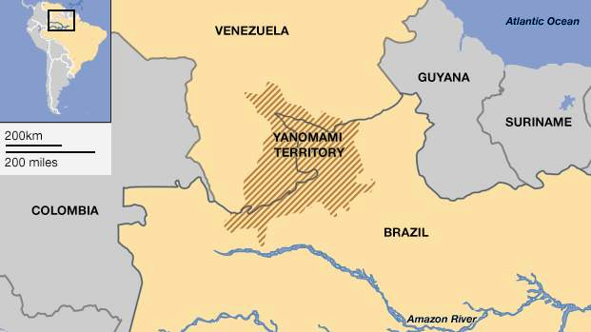

Fig. 2. Yanomami territory the putative origin of the ancestors of the Taíno (after the Hutukara Yanomami Association, The Venezuelan Government.

When these Yanomami women began their migration across the Antilles to Puerto Rico and Hispaniola (Lalueza-Fox 2001; Keegan 2007: 57) their homogeneous mtDNA genetic lineage was preserved. It may be suggested that the high position women had in Taíno society was due to the solidarity of these women.

These emerging ***Taíno*** chiefdoms depended on manioc and fish for their food with large ocean-going canoes carrying as many as 100 people in voyages of trade and exchange or of war. Interconnections with the South American and Meso-American mainland continued, as ideas and goods were exchanged.

In this complex mixture of Caribbean cultures, networks developed in which hybridized cosmologies, mythological themes and rituals and their accompanying material ritual objects, folktales, songs and dances were shared, exchanged and developed among Meso-America, South America and the Greater and Lesser Antilles.

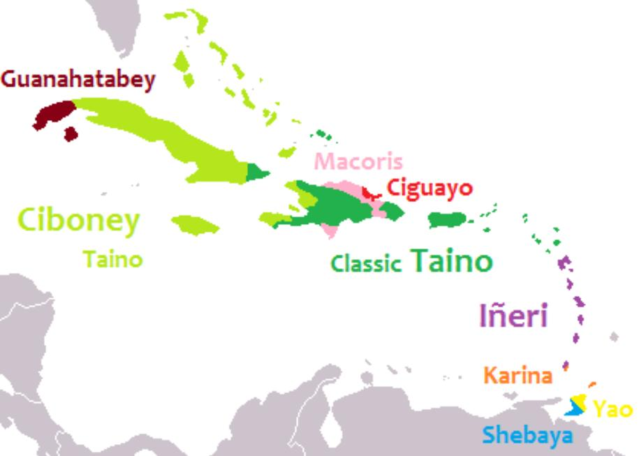

Fig. 3. Languages of the Caribbean, ca. 1492 (after Granberry and Vescelius 2004).

**Taino Language Groups.**At the time of contact, the Taíno were divided into three broad groups.

Guanahatabey was related to the earliest settlers of Cuba from the mainland and was unrelated to any of the Taíno dialects

Ciboney dialect (known as Western or Sub-Taíno) was spoken in Jamaica, most of Cuba, and the Bahamas. Those who spoke the Classic Taíno inhabited Hispaniola and Puerto Rico, and Eastern Taíno was spoken in the northern Lesser Antilles. Caribs of the southern Lesser Antilles spoke Ineri a language unrelated to Taíno dialects and were the traditional enemies of the Taíno.

Many Taíno words passed into Spanish in the fifteenth century. As the language of first contact, Taíno was one of the most important sources of Native American words for unfamiliar plants, animals, and cultural practices, and passed through Spanish to other European languages such as French and English. Below is a sample of English words derived from the Taíno (Granberry 2004: 101-122).

| **Ta**í**no** | **Meaning** | **English** | **Ta**í**no** | **Meaning** | **English** |
| --- | --- | --- | --- | --- | --- |
| barabakoa | cooking frame | barbecue | hurakã (/hodakã/?) | storm? | hurricane |
| kasik | chief | cacique | iwana | iguana | iguana |
| kaimã | crocodile | caiman | mahis, máhisi | maize | maize |
| kaniba | Carib | cannibal | manatí | manatee | manatee |
| kanowa | boat | canoe | papaya | papaya | papaya |
| kasabi | cassava | cassava | batata | potato | sweet potato |
| kaya | island | cay | sabana | less trees | savanna |
| seiba | ceiba tree | ceiba | taí-no | good people | Taíno |
| wayaba | guava | guava | tabako | tabacu | tobacco |

**Table 1. Correlation of Taíno and other related vocabularies**

**Taíno society*.*** Taíno society had two classes, *naborias* (commoners) and *nitaínos* (nobles). Male chiefs, *caciques*, who were advised by priests/healers known as *bohiques*. Caciques who were the chieftains of each of the island districts wore pendants of which some were of reddish copper-gold or *guanín*. Most of these were smelted down by the Spanish to send back to their Spanish royals to account for their apparent by delusional success in finding the gold that could pay off the debt incurred by the extirpation of the Jews and the Muslims from Spain in 1492. However, a number of stone artifacts, that to the Spanish had no value, have survived.

**Taíno Cemieism and Religion.** Taíno cosmology, religion and its rituals is described in Fray Ramón Pané’s *An Account of the Antiquities of the Indians*, the most important anthropological document on the Taíno that contains a wealth of information on this extinct culture. His commission from Columbus required him to record the Taíno beliefs and ceremonies as accurately as possible, and to that end he lived among the native Taíno population from 1493 to 1498. However, he was also a product of fifteenth century Roman Catholicism, and his primary goal was to convert the Taínos whom he regarded as heathens and idolaters. “[Some] were inclined to believe easily. But with others there is need for force and ingenuity because we are not all made of the same stuff. Although those people made a good beginning and a better end, there will be others who will begin well and afterwards will laugh at what has been taught them; with them there is need for force and punishment” (Pané p. 38).

Pané was a Catalan a Hieronymite monk of the Order of St. Jerome. These hermit monks lived according to the Rule of Saint Augustine, which stresses chastity, poverty, obedience, worldly detachment, physical labor, fraternal charity, common prayer, fasting and abstinence. Saint Jerome, a fifth-century hermit and biblical scholar, formulated the rules of the order. In the eyes of the Spanish church hierarchy, Pané was a poor Hieronymite hermit, a Catalan peasant not of Castilian origins and was dismissed probably for these social reasons by the Spanish Dominican Bartolomé de Las Casas (ca. 1484– 18 July 1566) as a “simple man” with “limited faculties” (Pané p. 57), whose efforts, “amounted to nothing more than to say the Ave María and Pater Noster to the Indians, and some words about there being a God in heaven who was the creator of things, according to what he was able to teach them with abundant flaws and in a muddled way” (Pané p. 57). However derogatory Las Casas’ criticisms of Pané are, Pané’s *Account* is still the best source of information on the Taíno.

However, Las Casas is also important for additional information he gathered on the Taino as well. Las Casas had immigrated with the expedition of Nicolás de Ovando to Hispaniola in 1502 and had become a *hacendado* and slave owner in the northern [now Dominican Republic] province of Cibao.[.](https://en.wikipedia.org/wiki/Bartolomé_de_las_Casas" \l "cite_note-11) He participated in slave raids and military expeditions against the native Taíno population of Hispaniola. As he became aware of the abuses of the Taíno that he was himself enslaving he decided to become a Dominican friar. In those time he could keep his hacienda but he was he was intellectually critical of poorly educated Hieronymites, being himself well-educated and connected with the church hierarchy. As an historian, social reformer and first resident Bishop of the state of Chiapas on the Pacific coast on southwestern Mexico. He was also officially appointed by the King as "Protector of the Indians," an administrative office responsible to the King for the well-being of Amerindians. To this end in *A Short Account of the Destruction of the Indies* written in 1542 and published in 1552 he documented Spanish atrocities committed against Amerindians including the Taíno and unabashedly sent it to Prince Philip II of Spain.

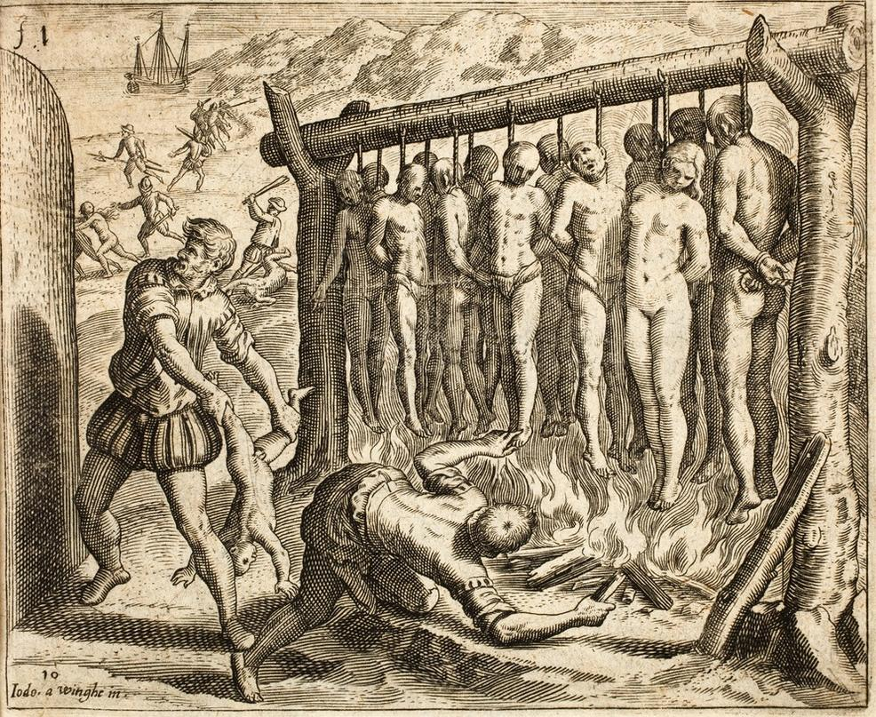

Fig. Depiction of Spanish atrocities committed against the Taíno in the conquest of Cuba in Las Casas' *Brevisima relación de la destrucción de las Indias* (1552). The rendering was by Flemish Protestant artist Theodor de Bry (1528 –1598) and Flemish Protestant engraver Joos van Winghe (1544–1603). Note that these two Protestants took an active role in disseminating evils of the Spanish *encomienda* or the grant by the Spanish Crown to a colonist in America that conferred the right to demand tribute and forced labor from Amerindian inhabitants in this publication by Las Casas, a Spanish Catholic Dominican.

According to Pané there were twelve orders of spiritual entities that exemplified energies of a Supreme Being. These energies were encompassed in *cemís* which were intermediaries, much like Judaeo-Christian angels or Roman Catholic Saints Since the repertoire of stone artifacts has now been relatively exposed to scientific scrutiny, each of the cemís spirits can be paired with its wood, stone, shell or textile material representation (Arrom 1975). The Taino also had a tripartite cosmos recorded by Pané which encompassed the sky, the earth and a lower world. These layered divisions are indicated on their most prominent artifact, the Three-pointed Sculpture.

The Taíno had a hidden god, YaYa, who was believed to be an immaterial spirit and whose name is a double superlative of the Arawak *Ia*, “spirit, essence, primary cause of life” or IaIa or YaYa, which can be translated as Spirit of Spirit (C. H. de Goeje, *The Arawak language of Guiana,* Amsterdam, 1928, pp. 45, 142, 204), and whom Father Pané says his “name is a name they do not know” (Pané, Account, ch IX). This is a sophisticated approach to a metaphysical entity that simultaneously exists as a primary cause and is unknowable. The Taíno believe that this entity “is in heaven [an Indo-European, Roman Catholic concept which has no immediate cognate in Taíno] and is immortal and that no one can see it and that it has a mother [which may mean a genesis] but no beginning” (*Relación* 21). This last statement sounds very Buddhist and if put in its stark simplicity it would say: “YaYa has a genesis but no beginning.” While this entity is unknowable and hidden, it simultaneously can be known through the effects it has on the material world. For instance, Pané indicates that the effects of this entity could be considered as manifestations of Yucahuguamá or Lord of the Yucca plant, the chief crop of sustenance of the Taíno (Relacion 48, n. 141).

In Taíno religion, therefore, just as in Hebrew religion or Roman Catholicism there is need for intermediaries between the known and the unknowable, and these are the cemís, which are known and have been represented in their material form, providing another very important window on the spiritual world of the Taíno.

**Taino Cemís: Three-pointed Stones**

The first category of cemí that we shall deal with is the Three-pointed Stone, usually sculpted of heavy andesite or marble. These are also referred to as tripointers. They have been divided into four categories by Jesse Walter Fewkes (1907:111-132) to which we have added a fifth type from eastern Hispaniola. We shall deal with the Three-pointed stones in an order of their probable temporal appearance among the Taino.

**1. Three-pointed Sculptures without Decoration (Fewkes Type 4.)** are probably the earliest representation since they have no decoration and are the smallest.

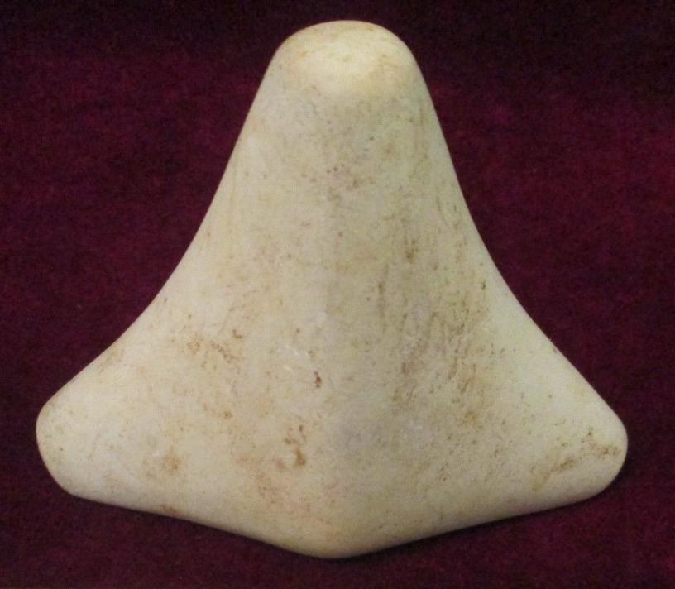

Fig.. **Three-pointed Sculpture without Decoration, 4.5 in long.** Dominican Republic. (Atlantika Collection no. F1969 .F4.1 )

These sculptures have important features. First, they have a pointed top, which has been likened to the *conucos* or mounds of the yucca plants. Secondly, this pointed top has also been likened to the shape of the holy mountain of the Taíno to which they ascribed their origin. Thirdly, in either case this pointed top shape is a metaphorical sign of fructification, which engenders a sense of fruitfulness among those who revere it.

**2. Three-pointed Sculptures with Three Zones .** This type is an addition to Fewkes’ typology and is represented by an example in stone and in shell.

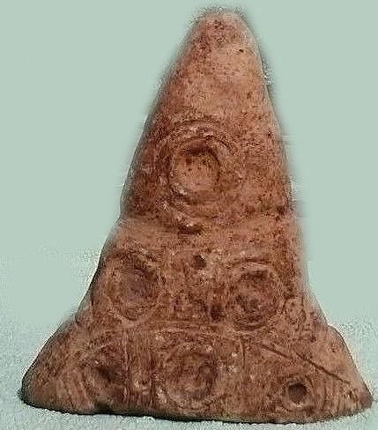 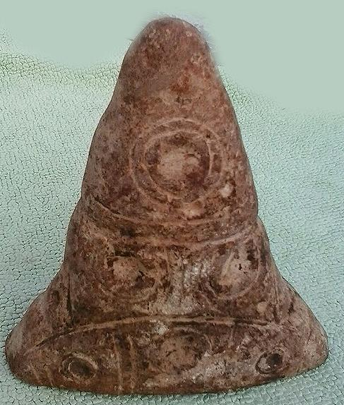 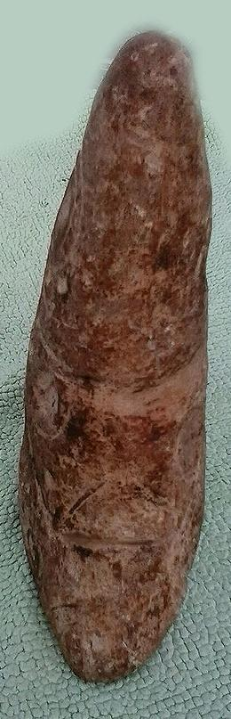

Fig. 11. **Three-pointed Sculpturee with Three Zones,** 7.5 by 6 by 2 inches; country of origin, Dominican Republic. (Atlantika Collection no. F1969 .F4.2 )

The main organizing structure of this Three-pointed Ssculpture is the separation of the stone into three zones or registers. In the example given in Fig. 11 three registers are separated by double line incisions. In each zone are concentric circles with one in the top register, two in the middle and three in the bottom. Concentric circles are associated with the navel or the source of “the life force” on anthropomorphic sculptures. Taíno geometry on this sculpture suggests a tripartite universe: with the solar disk on the top, the middle region of earth, which is alive with animals and plants, and the lower region, which encompasses the ancestors (represented by their cemis on earth). This design grammar is comparable to that in the shell artifact below.

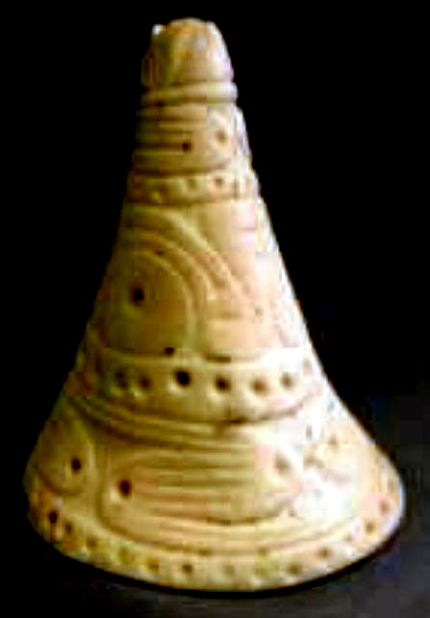

Fig. 12.  **Saladoid conical shell cemi, Montserrat**

The Saladoid conical shell in Fig. 12 from Montserrat conforms to the geometry for the Type 5 Three-pointed Stone. It clearly shows the separation of three zones within which are Sigma curvilinear elements 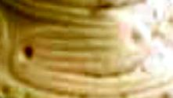. The bottom and the top curvilinear elements signify the motion of the hurricane as it swirls in a spiral motion.

**3. Three-pointed Stone with “head on anterior and legs on posterior projection.”**

The classification of this type is based mainly on the anterior depiction of an anthropomorphic head. The axis of the base is sometimes skewed to the left or right, suggesting that the sculptor intended to indicate left or right-handedness. A generally smooth surface may be marked by incised or ground lines suggesting anatomical features, and ground cupules usually indicate anatomical joints and the spine. In rare instances anterior as well as posterior limbs are indicated (Fewkes 1907: 111).

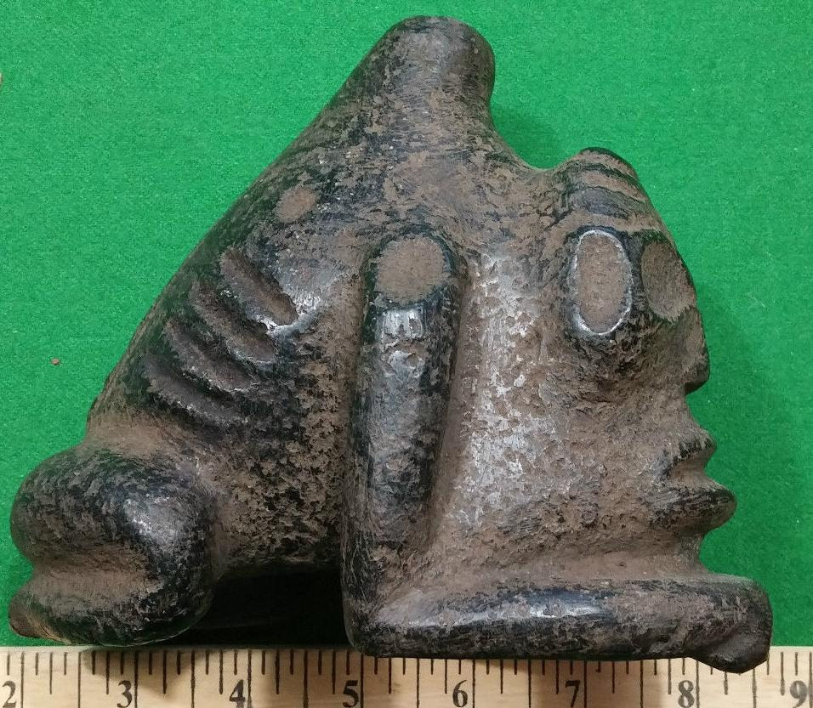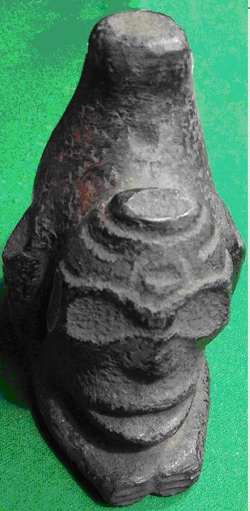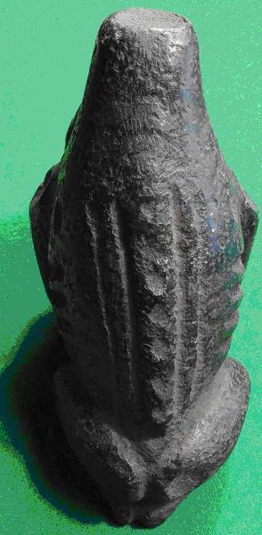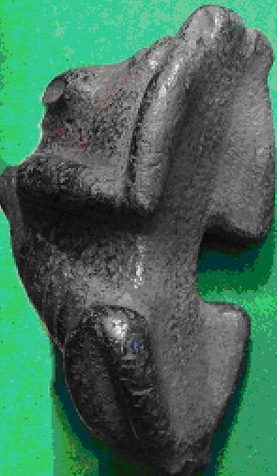

Fig. 4 a-d. Three-pointed Stone, Fewkes Type 1, rare type, anterior and posterior anthropomorphic limbs with rudimentary feet. The axis of the body is skewed to the left. Jesse Walter Fewkes has speculated that a left-leaning bias on these stones may imply an attempt to distinguish left-handedness. (Atlantika Collection no. F1969 .F4.3 )

Cupules are placed at critical points. The pointed protuberance on the sculpture of Fig. 4a is topped by a cupule. This protuberance has been likened to a volcanic cone as a symbol of the sacred origin of the Taino from their volcanic island home. Seven cupules mark the spinal column. The euphoria that ascends the spine after having inhaled the cohoba hallucinogen could be interpreted as ascending the spine. Cupules are placed at the top of the forearms, at the top of the rib cage and on the buttocks. The figure wears a special conical, ribbed cap on its forehead, with a cupule on its front and top. Such caps are found on other figures that suggest they are shamanic emblems. A final cupule is located just behind the cap, perhaps signifying the omniscience of the volcanic spirit.

The ribs of the anthropomorphic figure are clearly shown suggestive of fasting, which, when combined with the enlarged eyes and the rudimentary lower appendages, suggest a sedentary individual in a meditative posture.

The underside of the sculpture (Fig. 4d) is grooved to fit a curved object such as a stone collar that was used in the ballgame. A single lash could have easily encircled this three-pointed stone to the collar in its middle as had been shown for a similar artifact by Fewkes with a double lash at either end (Fewkes 1907: Plate LXIXa).

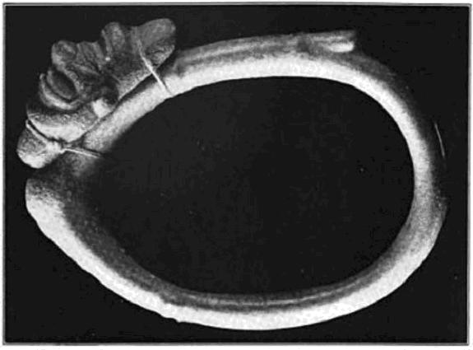

Fig. 5. Stone collar showing method of attachment of a grooved three-pointed stone. Collar, 16.5 in. dia. (after Fewkes (1907: Plate LXIXa).

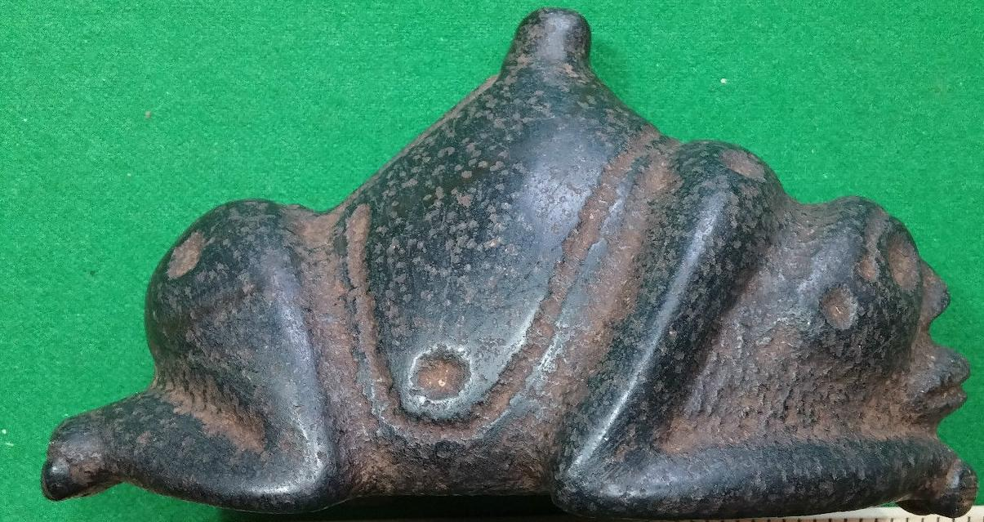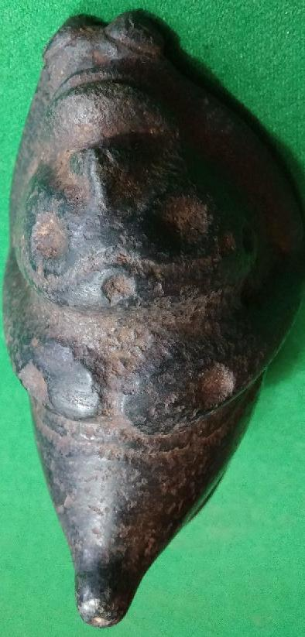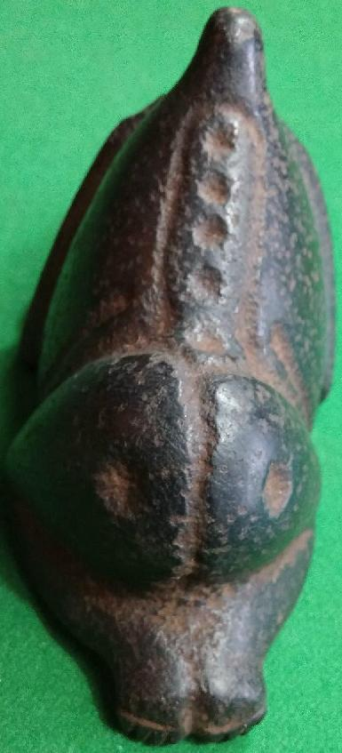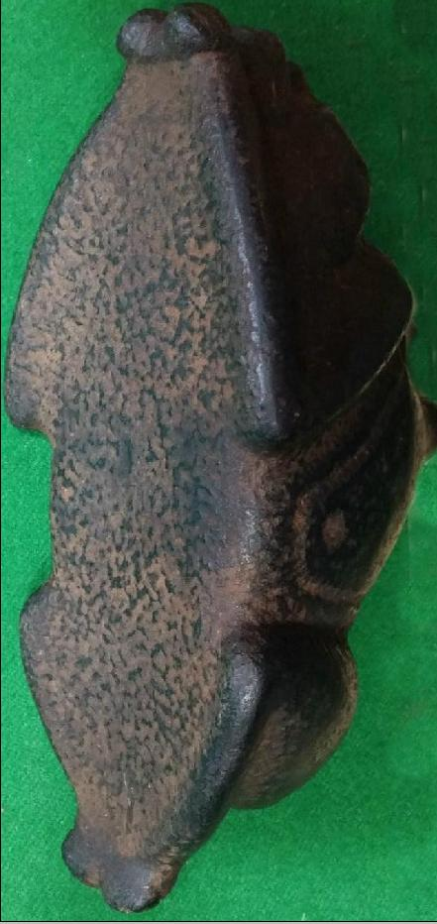

Fig. 5. Three-pointed Stone, Type 1, anterior and posterior limbs with feet developed, Group 1 with human head. The axis of the body is skewed to the right. There are five cupules to denote the spine. Fig. 6d shows a midriff groove to (possibly) accept lashing to a stone collar (Atlantika Collection no. F1969 .F4.4 ) are indicated.

The sculpture in Fig. 5 has a slight skew to the right. In this sculpture these is no hint of ribs being exposed, and the eyes are much smaller than in the three-pointed stone in Fig. 4. The underside shows a much less developed groove to make an attachment to a stone collar, but there is a midriff groove made by the anterior and posterior appendages that could have been used to secure it onto a flat surface.

The Three-pointed Stone in Fig. 4 has exposed ribs suggesting abstinence and large eyes suggesting sight in a nocturnal environment. This suggests a spiritual rite associated with a visionary quest. The three-pointed stone in Fig. 5 suggests a different spiritual orientation. There is no vestige of exposed ribs, and the eyes are pointed straight ahead as if scrutinizing the landscape, It is therefore tentatively suggested that these two three-pointed stones served different ceremonial purposes, one nocturnal and spiritual and the other associated with daylight and activity.

4. **Three-pointed Stone with conoid projection modified into a head (Fewkes type 3.)**

This Three-pointed Stone represents the Goddess of fertility, the "Spirit of the Yucca and the sea”. It was buried in a conucos to further the growth of the yucca plant, the main food of the native ***Taíno***. This type has the image of the deity on top facing upwards as if in supplication and is the rarest of the Three-pointed Stones. Fewer than ten have been found.

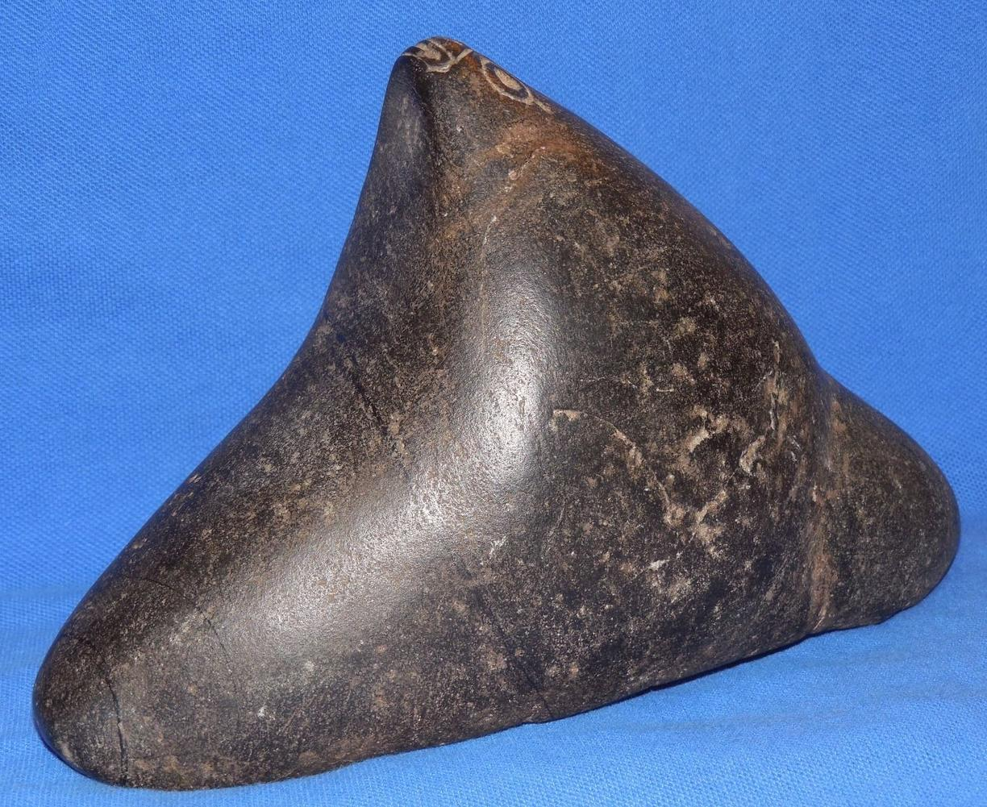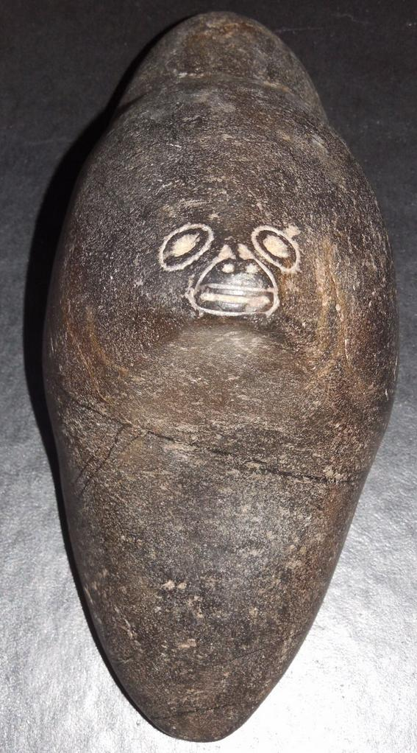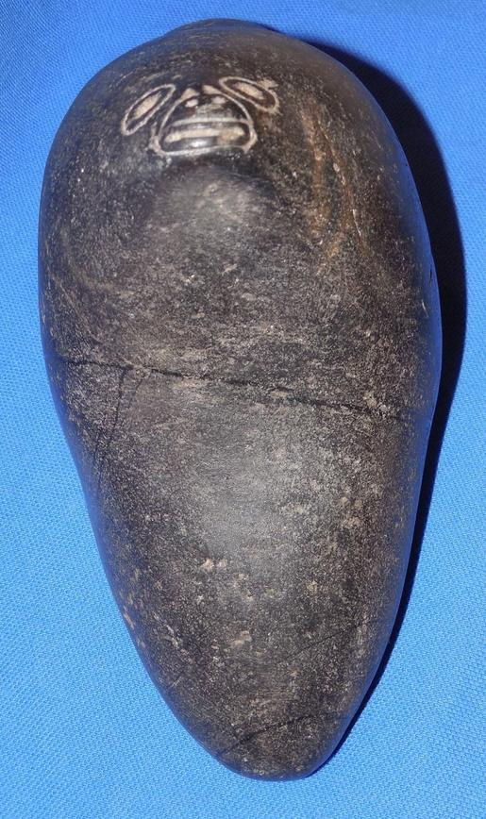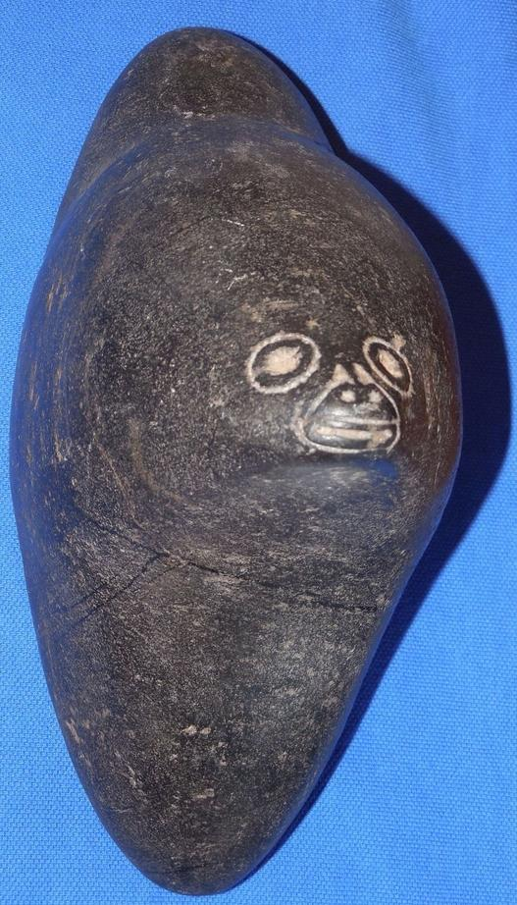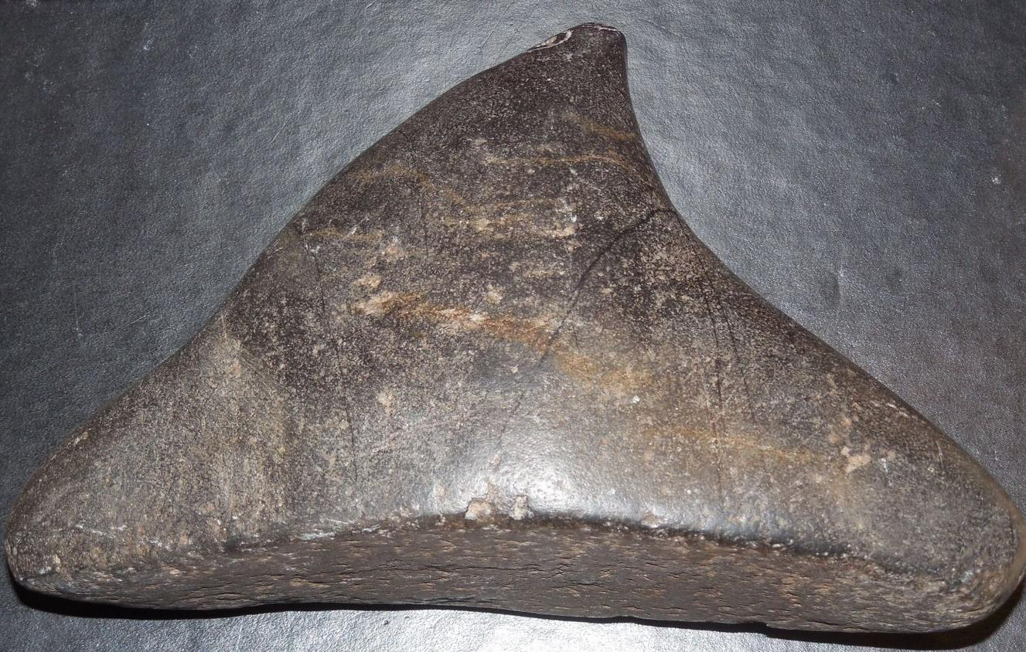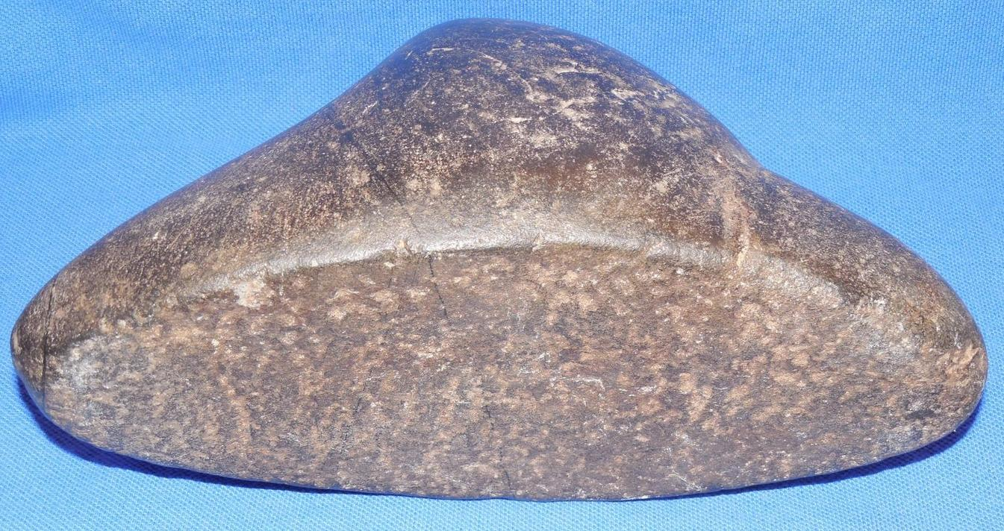

Fig. 9. Type with conoid projection modified into a head. (Fewkes 1907:125-127). This is considered by Fewkes as the rarest type, and 3 of the 4 examples that are in the Smithsonian originated in Santo Domingo. However this specimen is for its facial design that is related to a similar facial design on a type 2 Three-pointed stone from the Dominican Republic.

# Cemi Figurines and their Religious Meanings

# Yaya, Yaca huguamá, Yucahú

The names of the high deity of Taíno theology is the superlative

## Boa

The *Bohuitihu* priests of the patron mother goddess *Guabancex* when commissionedto visit the sick and infirmed, they would cover their faces with charcoal in order to assume the metaphoric pallor of the patients they were visiting. It is this metaphoric commonality the *Bohuitihu* assumed the disorder that would put them in the same psycho-physiological demeanor that they could then assume with the ill and then begin the process of mutual healing. The role of healing psychology was prominent in this endeavor. The connection with the mother goddess was essential also, since “These priests always carried the image of the *cemí* and were known by her name so they were called *cemís* as well *bhiu*” (Pané in Mendez 1957, I: 74). *Bohiqu*e is another name for the priest *bohuitihu*, derived from the phoneme *bohio*-house and *boa* –serpent. Since the priests received healing powers from snakes they relied on them when they were in danger, especially in the acts of healing the sick when they were required to travel outside of their bodies, as “the *cemís* came to their rescue in the form of serpents” (Pané in Mendez 1957, I: 23).

This stone sculpture of serpent would have been such a *cemí* that was brought to the place of healing, with the tail encircling a solar disc motif of the patron mother goddess *Guabancex*. It is also possible that the encircled tail also was a receptacle for some of the *cohoba* powder that was used in the purification ceremony.

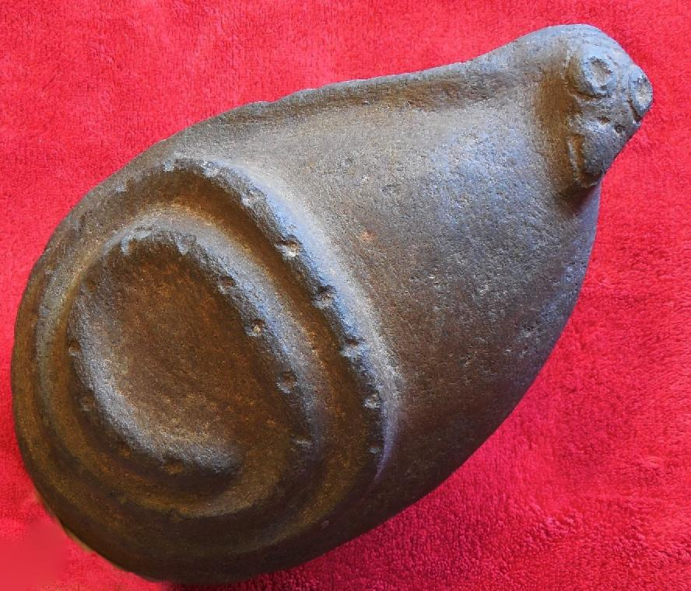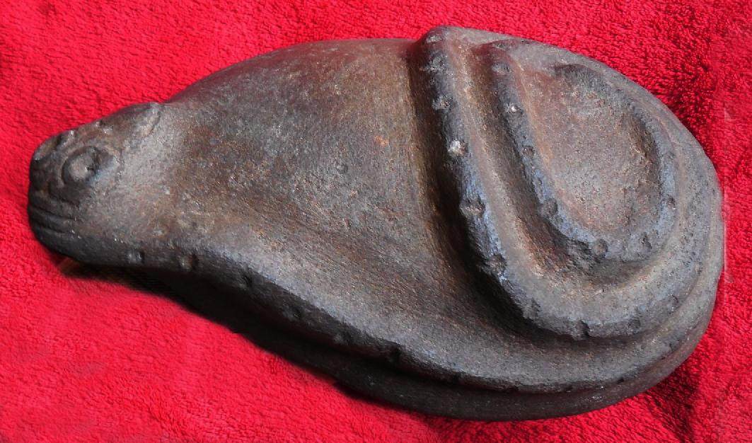

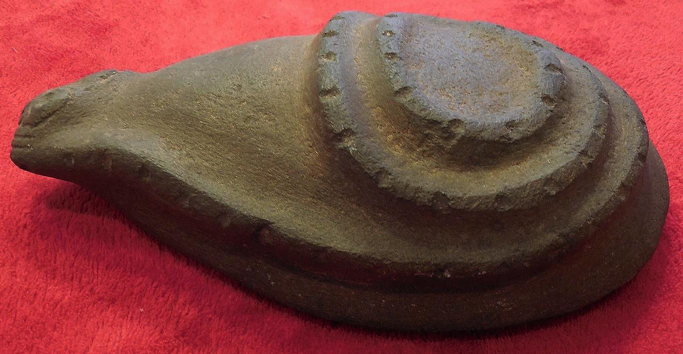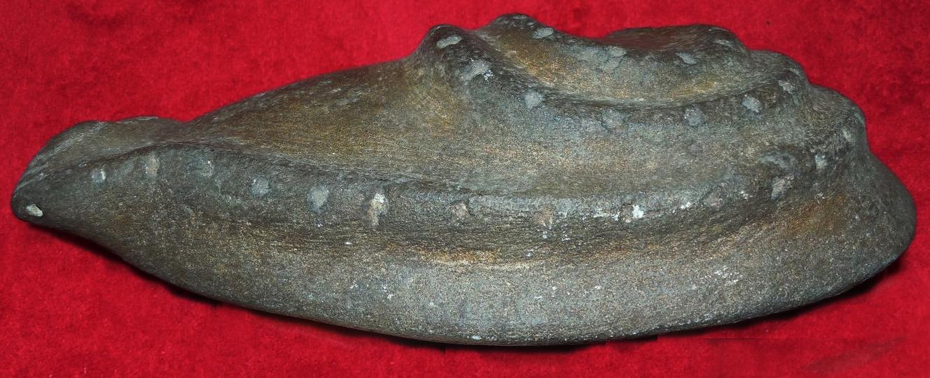

REFERENCES

Bower, B

1994 Maya Beginnings Extend Back at Belize Site. Science News 145(18):279.

Bullen, R. P.

1976 The Preceramic Periods of Florida and the Lesser Antilles. In Proceedings of the First Puerto Rican Symposium on Archaeology, edited by L. S. Robinson, pp. 9-23. Fundacion Arqueol6gica, Antropologica e Historica de Puerto Rico, San Juan

Callaghan, R. T.

1990 Possible Pre-ceramic Connections Between Central America and the Greater Antilles. Proceedings of the Eleventh Congress of the International Association for Caribbean Archaeology,

1985, pp. 65-71, Puerto Rico.

1991 Passage to the Greater Antilles: An Analysis of Watercraft and the Marine Environment. Proceedings of the Fourteenth Congress of the International Association for Caribbean Archaeology, 1989, pp. 64-72, Barbados

Coe, W. R., II

1957 A Distinctive Artifact Common to Haiti and Central America. American Antiquity 22:280-282.

Cruxent, J. M., and I. Rouse

1969 Early Man in the West Indies. Scientific American 221(5):42-52.

Gerrell, P. R., J. F. Scarry, and J. S. Dunbar

1991 Analysis of Early Archaic Unifacial Adzes from North Florida. The Florida Archaeologist44(1):3-16.

Giménez Fernández, Manuel (1971). "Fray Bartolomé de Las Casas: A Biographical Sketch". In Friede, Juan; Keen, Benjamin (eds). Bartolomé de las Casas in History: Toward an Understanding of the Man and his Work. Collection spéciale: CER. DeKalb: Northern Illinois University Press. pp. 67–126.

Hester, T. R.

1994a An Introduction to the Colha Preceramic Project.

Paper presented at the 59th Annual Meeting of the Society for American Archaeology, Anaheim.

1994b The Archaeological Investigations of the Colha Project, 1983 and 1984. In Continuing Archaeology at Colha, Belize, edited by T. R. Hester, H. J. Shafer, and J. D. Eaton, pp. 1-9. Texas Archaeological Research Laboratory, University of Texas, Austin.

Hester, T. R., H. J. Shafer, and T. C. Kelly

1980 A Preliminary Note on Artifacts from Lowe Ranch:

A Preceramic Site in Belize. In The Colha Project Second Season, 1980 Interim Report, edited by T. R.

Hester, J. D. Eaton, and H. J. Shafer, pp. 229-232. Center for Archaeological Research, University of Texas, San Antonio, and Centro Studi Ricerche Ligabue, Venezia. San Antonio.

Hester, T. R., H. Iceland, D. Hudler, R. Brewington, H. J. Shafer, and J. Lohse

1993 New Evidence on the Preceramic Era in Northern Belize: A Preliminary Overview. The Newsletter of the Friends of the Texas Archeological Research Laboratory 1(2): 19-23.

Hester, T. R., H. Iceland, D. Hudler, and H. J. Shafer

1996 The Colha Preceramic Project. Mexicon XVIII (3): 50.

Hudler, D. B., T. R. Hester, and H. B. Iceland

1995 The Colha Preceramic Project: A Status Report.

Paper presented at the 60th Annual Meeting of the Society for American Archaeology, Minneapolis.

Iceland, H. B., and T. R. Hester

1996a The Colha Preceramic Project: A Status Report.

Paper presented at the 61st Annual Meeting of the Society for American Archaeology, New Orleans.

1996b The Earliest Maya? Origins of Sedentism and Agriculture in the Maya Lowlands. Preprints of the XIII International Congress of the Prehistoric and Protohistoric Sciences, Forli, Italy, September 1996, in press.

Iceland, H. B., T. R. Hester, H. 1. Shafer, and D. Hudler

1995 The Colha Preceramic Project: A Status Report.

The Newsletter of the Friends of the Texas Archeological Research Laboratory 3(2): 11-15.

Jacob, J. S.

1995 Ancient Maya Wetland Agricultural Fields in Cobweb Swamp, Belize: Construction, Chronology, and Function. Journal of Field Archaeology 22: 175-190.

Jones, J. G.

1994 Pollen Evidence for Early Settlement and Agriculture in Northern Belize. Palynology 18: 205-211.

Kelly, T. C.

1993 Preceramic Projectile-Point Typology in Belize.

Ancient Mesoamerica 4:205-227.

Lohse, 1. C.

1993 Operation 4046 Colha. Belize: A Reconsideration of a Lowland Archaic Deposit. Unpublished M.A. Thesis, Department of Anthropology, University of Texas, Austin.

MacNeish, R, S., and A. Nelken-Turner

1983 Final Report of the Belize Archaic Archaeological Reconnaissance. Center for Archaeological Studies, Boston University, Boston.

MacNeish, R. S., 1. K. Wilkerson, and A. Nelken-Turner 1980 First Annual Report of the Belize Archaeological Reconnaissance. Phillips Academy, Andover.

Mendez, Eugenio Fernandez. 1957. Crónicas de Puerto Ricao desde la conquista hasta nuestros dias. San Juan, Ediciones del Gobierno estado Libre Asociado de Puerto Rico.

Moore, C.

1991 Cabaret: Lithic Workshop Sites in Haiti. In Pro­ceedings of the Thirteenth Congress of the International Association for Caribbean Archaeology, edited by 1. Haviser and E. N. Ayubi, pp. 92-104. Reports of the Archaeological-Anthropological Institute of the Nether­lands Antilles, No.9. Willemstad, Curacao.

Oliver, J. R. 2009. Caciques and cemi idols: the web spun by Taíno rules between Hispaniola and Puerto Rico. Tuscaloosa: University of Alabama Press.

Pané, Fray Ramón. *An Account of the Antiquities of the Indians.* Trans. José Juan Arrom and Susan C. Griswold. Durham: Duke UP, 1999.

Pantel, A. G.

1988 Precolumbian Flaked Stone Assemblages in the West Indies. Ph.D. dissertation, University of Tennessee. University Microfilms, Ann Arbor.

1991 How Sophisticated was 'the Primitive'? Pre-ceramic Source Materials, Lithic Reduction Processes, Cultural Contexts and Archaeological Inferences. Proceedings of the Fourteenth Congress of the International Association for Caribbean Archaeology, pp. 157-169. Barbados.

1994 Prismatic Blade Technologies in North America. In Organization of North American Prehistoric Chipped ­Stone Tool Technologies, edited by P. 1. Carr, pp. 87-98. Archaeological Series NO.7. International Monographs in Prehistory, Ann Arbor.

Peterson, J. B., C. L. Hofman, and L. A. Curet. 2004. Time and culture: chronology and taxonomy in the eastern Caribbean and the Guianas, in A. Delpuech and C. L. Hofman, eds., Late Ceramic age societies in the eastern Caribbean (British Archaeological Reports international series 1273): 17-32. Oxford: Archaeopress.

Rouse, I.

1941 Culture of the Ft. Liberti Region, Haiti. Yale University Publications in Anthropology, No. 26. New Haven.

1960 The Entry of Man into the West Indies. Yale University Publications in Anthropology, No. 61. New Haven.

1964 Prehistory of the West Indies. Science 144: 499-513.

1986 Migrations in Prehistory. Yale University Press, New Haven.

1992 The Tainos. Yale University Press, New Haven.

Shafer, H.

1991 Late Prec\assic Formal Tool Production at Colha, Belize. In Maya Stone Tools, edited by T. R. Hester, H. 1. Shafer, and 1. D. Eaton, pp. 25-30. Texas Archaeological Research Laboratory, University of Texas. Austin.

Shafer, H. 1., T. R. Hester, and T. C. Kelly

1980 Notes on the Sand Hill Site. In The Colha Project Second Season, 1980 Interim Report, edited by T. R. Hester, 1. D. Eaton, and H. 1. Shafer, pp. 233-240. Center for Archaeological Research, University of Texas, San Antonio, and Centro Studi Ricerche Ligabue. Venezia.

Steward. 1. H.

1948 The Circum-Caribbean Tribes: An Introduction. In Handbook of South American Indians, vol. 4, The Circum-Caribbean Tribes, edited by 1. H. Steward, pp. 1--41. Bureau of American Ethnology Bulletin 143(4), Washington, D.C.

Stuiver, M., and R. S. Kra

1986 Calibration Issue, Proceedings of the 12th International 14C conference. Radiocarbon 28: 805-1030.

Stokes, A. v.. and W. F. Keegan

1993 A Settlement Survey for Prehistoric Archaeological Sites on Grand Cayman. Miscellaneous Project Report Number 52, Florida Museum of Natural History, Gainesville.

Veloz Maggiolo, M.

1976 Medioambiente y adaptacion humana en La prehis­toria de Santo Domingo. Universidad Autnoma de Santo Domingo, Santo Domingo, Republica Dominicana.

Veloz Maggiolo, M., and B. Vega

1982 The Antillean Pre-ceramic: A New Approximation.

Journal of New World Archaeology 5(2):33--44.

Wilson, S. M.

1996 The Rise of Complex Societies in the Caribbean.

Preprints of the XIII International Congress of the Prehistoric and Proto historic Sciences, Forlf, Italy. September 1996.

Samuel M. Wilson, Harry B. Iceland and Thomas R. Hester 1998 Preceramic Connections between Yucatan and the Caribbean Latin American Antiquity, Vol. 9, No.4 (Dec.), pp. 342-352.

Wood, G. P.

1990 Excavations at OP 4046, Colha, Belize: A Buried Preceramic Lithic Deposit. Unpublished M.A. thesis, Department of Anthropology, University of Texas, Austin.

Zeitlin, R. N.

1984 A Summary Report on Three Seasons of Field Investigations into the Archaic Period Prehistory of Lowland Belize. American Anthropologist 86:358--368.

Zeitlin, R. N., and 1. F. Zeitlin

1996 The Paleoindian and Archaic Cultures of Mesoamerica. In The Cambridge History of the Native Peoples of the Americas, edited by R. E. W. Adams and M. MacLeod. Cambridge University Press, Cambridge.